WSP-515 Map

WS-P 23.1H: To support Map functionality in WS-P.

|  |  |  |  |
| --- | --- | --- | --- |
|  | | |  |
| Author | Mohamed Ibrahim M |
| Contributor | Dama, Kiran, Harish K, Harish S, Naga |
| Organization | Nokia |
| |  |  |  |  |  |  |  |  |  |  |  |  |  |  |  |  |  |  |  |  |  | | --- | --- | --- | --- | --- | --- | --- | --- | --- | --- | --- | --- | --- | --- | --- | --- | --- | --- | --- | --- | --- | | **Change History**   |  |  |  |  | | --- | --- | --- | --- | | **Version** | **Date** | **Author** | **Description of changes** | | 1.0 | 11/11/2022 | Mohamed Ibrahim | Initial Draft (Feature Overview, Design Overview, User Interface Design, Rest Interface, Test Strategy, Open Issues) | | 2.0 | 23/11/2022 | Mohamed Ibrahim | Review comments addressed (Feature Overview, Design Overview, Test Strategy) | | 3.0 | 2/12/2022 | Mohamed Ibrahim | Addressed SE review comments | | 4.0 | 29/06/23 | Mohamed Ibrahim | Added new features | | |  | |  | | Contents  1 Feature Overview 4  1.1 Summary 4  1.2 Requirements 4  1.3 Design Considerations 5  1.3.1 Impacted areas 7  1.4 Configuration Information 11  1.5 Target Customer and Customer Network (if available) 11  2 Design Overview 11  2.1 Assumptions 12  2.2 Constraints 12  2.3 Risks 12  2.4 Functional Areas covered by the design 12  2.4.1 Use Cases 12  2.4.2 Feature/Sub-feature Enabling 13  2.4.3 Limitations 13  2.5 Operation Workflow 14  2.5.1 Map Data Map 14  2.5.2 Map Menu and Settings Functionalities - (Menu) 14  2.5.3 Map Geo view and Geo-free view 14  2.5.4 Geocoding 15  2.5.5 User Preference 15  2.5.6 Loading/Opening design 16  2.5.7 Fast Mode Creation 16  2.5.8 Layer View 17  2.5.9 Show Route 18  2.5.10 Map-Icon interaction 18  2.5.11 Taskbar interactions and Window-window communication: 18  2.5.12 Map-Mouse Interaction 19  2.5.13 Notifications 19  2.6 Process/Functional Flow 19  2.6.1 Map Menu and Settings 19  2.6.2 Geocoding 20  2.6.3 Geo view and Geo-free view 20  Users can switch between geo view and geo-free view by selecting the respective menu in map context menu. Users can see geo coordinates in site creation and edit window in geo free mode, the geo coordinates and the address will be non-editable. 20  Users can freely move the sites in geo-free view but for R23.7.0 it will be restricted within the map boundary. When the user moves the site in the geo free view only geo free coordinates will be updated internally, and the geo coordinates will not be disturbed. When the user edits the geo coordinates in the geo view, the non geo coordinates will not be disturbed. The bottom information table will always display geo coordinates. 20  2.6.4 User Preference 20  2.6.5 Loading/Opening design 20  2.6.6 Layer View 20  2.6.7 Show Route 21  2.7 EPT Engine Dependencies 21  2.8 Object and Data Model 21  2.9 Solution Context/GNP 21  2.10 Configuration Data 21  2.11 Persistence 21  2.12 Database 22  2.12.1 Geocoding 22  2.12.2 User Preference 22  2.13 Data Migration/Upgrade 22  2.14 Design Features 22  2.14.1 Performance 22  2.14.2 Scalability 22  2.14.3 Security 23  2.14.4 Concurrency 23  2.14.5 Error/Exception Handling 23  2.14.6 Disaster Recovery 23  2.14.7 Transaction Strategy 23  3 User Interface Design 23  3.1 Loading Design 23  3.2 Map Menu & Map Settings 24  3.3 Map Mouse Interactions 25  3.4 Map Geo-free view: 27  3.5 Moving site 28  3.6 Layer View and Show Route 29  3.7 Geocoding 31  4 REST Interface 31  4.1 Loading Design 32  4.2 FastMode 32  4.3 Preferences 32  4.4 Geocoding 33  4.5 Layer View and Show Route 33  5 Test Strategy 33  6 Open Issues 34  7 Appendix 34  7.1 Configurations not supported or limitations 35  7.2 PlantUML or Other Files for Diagrams in the Design Document 35  8 Review Comments 35 | | |  |
|  | | |  |

General Instructions

Basic Requirements:

Include a Table of Contents

All sections, including headings, subheadings, and tables, must be included, and filled in.

If some section is not applicable, explicitly identify that with “Not Applicable”.

If something is yet to be determined or otherwise under investigation, indicate that and reference the Jira ticket under which this will be determined with the ticket key as a hyperlink and the ticket title/summary indicated. If there is no Jira ticket explicitly covering the open item, create one (likely a sub-task under a story).

Make sure to verify all the checklists for use-cases, components, and network configurations.

Proofread for typos and grammatical errors before review.

Note format for Jira ticket references: <hyperlinked key>: <*Jira Summary*>

For example, [WSP-508](https://optics-jira.ext.net.nokia.com/browse/WSP-508): *Infrastructure*

# Feature Overview

This Epic [WSP-515](https://optics-jira.ext.net.nokia.com/browse/WSP-515) supports the Map functionality in WS-P.

## Summary

This EPIC provides the map functionalities for the selected design. It covers loading of entities as SVG icons in the map. It also covers the following and its functionalities which are supported in 22.07:

* User interactions in map
* Menu filtering
* Map-mouse interactions
* Show Route & Layer View for demands (Trail and Service)

## Requirements

* Loading and plotting the entities on the Map while opening the selected design.
* Handling/Populating respective event handlers/pop up menu items for each entity.
* Highlighting the entities on selection
* Handling Map Menu and its functionalities
* Handling Map Settings and its functionalities
* Handling User preference saving and retrieval
* Handling layer view and show route for demands (Trail and Service)
* Fastmode creation of entities in the map
* Geocoding
* Edge details viewer
* NRA interactions support
* Map mouse interactions for different view
* Taskbar and window-window communication functionalities
* Switching between Geo and Geo-free view
* Moving site in the map

## Design Considerations

|  |  |  |  |
| --- | --- | --- | --- |
| Area | Applicability (Y/N) | If not applicable, why not? | If yes, which section covers |
| Data Model Usage (WS-P and/or EPT) | Y |  | To display entities on the Map |
| Data Model Changes (WS-P and/or EPT) | Y |  | For User Preferences, GeocodingData  (WS-P)  Entity DTO adjustments if required (Will be handled with the help of respective teams) |
| EPT Engine Support | Y |  | Require support for Loading design,  Show Route,  Layer View |
| Network Configuration (Nodes, Cards, NEs, Interworking) | N |  |  |
| Version Mix of the Nes | N |  |  |
| Scale (Size of network, # of connections, # of TPs). | Y |  | Loading Design |
| Upgrade (Design & Release) | N |  |  |
| Migration | N |  |  |
| Data persistence – Process/Container/VM Restarts | N |  |  |
| Greenfield/Brownfield | N |  |  |
| Concurrency (Process and/or Thread) | Y |  | Fast Mode Creation |
| Resource Utilization/Footprint | Y |  |  |
| Data Integrity | N |  |  |
| Performance | Y |  | Fast Mode Creation,  Loading Design,  Layer View, Show Route |
| HA/DR | N |  |  |
| External Interfaces | N |  |  |
| User Activity Logging | N |  |  |
| Jobs | N |  |  |
| User Experience   * Ease of Use/Workflow * Consistency | Y |  |  |
| Overflow Control | N |  |  |
| Boundary Conditions | N |  |  |
| Error/Exception Handling | Y |  |  |
| Naming in Code (Classes, Interfaces, etc.) | Y |  |  |
| REST Interface changes   * Impacts to clients * Backward compatibility | Y |  |  |
| Data backup (including data and config files) and overflow strategy | N |  |  |
| User Type & Permissions | Y |  | Geocoding |
| SW & SVT Testing | Y |  |  |
| Dependency on Existing features (and assumptions about how those features work for the epic to work). | Y |  | Loading Design, Fast Mode Creation |

### Impacted areas

|  |  |  |  |
| --- | --- | --- | --- |
| Functional Area | Impacted or not | If not, why not | If impacted, describe |
| Network Specification   * Solution Context/GNP * Topology Specification * (Multi-Layer) Trail/Service Specification * Import (EPT, WP, Excel) * Templates | Yes |  | Site creation involves Geocoding |
| Plan/Design Management   * Plan CRUD Operations * Design CRUD Operations * Import WS-P Design * Export WS-P Design * Check In/Check Out/Revert Design * Clone Design | Yes |  | Exposing menus for check-in and export design from Map under hamburger menu  Export design impacted by preference |
| Design Operations   * Remove Design * Auto Design * Verification * Design State Calculation * Manual Routing/Edit Route * Link Optimization * Channel Management * Bandwidth Defragmentation | Yes |  | Reloading map after run design |
| Auto Design Solution   * Design Prep/Freeze Support * Routing * Wavelength Assignment * Equipment Selection * Power/Gain/Equipment Settings * Physical Realization * Verification | No |  |  |
| Manual/Edit Design   * Create/Edit Route * Path Analyzer * Wavelength Assignment * Equipment Selection/Edit * Power/Gain/Equipment Settings * Physical Equipment Edit * Verification | No |  |  |
| Visualization/UI   * Map   + Layer View   + Heat Map   + Route View   + NRA Support   + Object & Template Support * Design App Tables * Object Create/Edit Panels * NE Edit Panel * OMS Panel * Node Panel * Schematic Panel * CPLR * Channel Utilization | Yes |  | Layer View, Show Route, Mouse interactions for NRA  Highlight entities in bottom table  Menu items for Templates to be supported in Map menu – Functionality handled as part of [WSP-534](https://optics-jira.ext.net.nokia.com/browse/WSP-534) |
| Reports   * Network Information Report * Equipment Report/Card Inventory report/Rack report * BOM Report * Installation Report * Physical Layer Report * OT Segregation/ASE Noise Report * Table Information report * Visio Report * Available Resources Report * Channel Utilization report * Log Report | Yes |  | Visio report generation menu to be supported in Site menu for Map  Functionality covered as part of  [WSP-538](https://optics-jira.ext.net.nokia.com/browse/WSP-538) |
| GMPLS   * Failure Scope/Sequence Management * SRG Management * GPC Management * NRA/GMPLS Audit * GMPLS Report | Yes |  | Map-mouse interaction support while creating failure scope, NRA |
| Network Lifecycle   * Commissioning * Upload (EPT Style) * Create Design from NDF (WP Style) * Discrepancy Report * Merge with Deployed Actualization * Network Audit * Backward Compatibility/NE Upgrade | Yes |  | Map-mouse interaction support while system creation |
| Infrastructure   * Jobs * Logging * Notifications * Error Management * Multi-Instance * Session Management * Performance * Scalability * Security * EPT Cut-Through * Process Management/Monitoring | Yes |  | Depends on Notifications  Error Management, Scalability, Performance, Security |
| Data Model/DTO & Associated Operations   * Site * NE/Shelf/Pack * Node * Segment (Span in WP) * WDMLink/OMS * Span (OTS in WP) * System * Transparent Link/OCH * Trail * Service * Error * Failure Scenario/SRG * Phase/Project | No |  |  |
| OA&M   * User CRUD * User Type/Permissions/Auth * User/Design Management/Sharing * DB Management * Persistence * Installation * Start-up * Release Upgrade * Licensing * Backup/Restore * High Availability/Disaster Recovery | Yes |  | Database tables in WS-P for maintaining Geocoding Data and User Preference |
| Configuration Data Management   * CDS * Configuration Files (EPT or WS-P) * Price file | No |  |  |
| REST Interface   * Standard * Client-specific * Public/Private * Swagger Support * Programmatic Client Support | Yes |  |  |
| User Documentation | Yes |  |  |

## Configuration Information

NA

## Target Customer and Customer Network (if available)

All the customers supported in 22.07

# Design Overview

## Assumptions

* + To use the entity icons as in WP and retain the Map functionality exactly as in WP
  + Composite nodes will not be supported
  + Phases and Group will not be supported
  + OTU, ODU, Section will not be supported

Note: The naming convention for entity is still under discussion but as of now will be going forward with WP naming will be confirmed by SE later

## Constraints

NA

## Risks

Identifying and exposing EPT methods for Layer View and Show Route(Failure scope and restoration route details)

## Functional Areas covered by the design

Map involves operations to populate entity and its associated user interactions. It also involves Layer View and Show Route of demands.

**Supported entities on map:**

* + - Sites
    - Node
    - NEs
    - Span in WP – Segment in EPT
    - OTS in WP – Span in EPT
    - OMS in WP – WDMLink in EPT
    - OCH in WP -Tlink in EPT
    - Demands (Trails and Services)

### Use Cases

* Loading entities on opening a design
* Geocoding
* Geo-view and Geo-free view
* Moving site
* Fast Mode Creation of site, node and segment (span)
* Saving Preferences
* Map Icons Interaction
* Map Settings
* Map Menu
* Edge details viewer
* Layer View and Show Route for demands (Trails and Services)
* Taskbar Interactions
* Window to Window communications if required
* Map Mouse Interactions for respective view (Respective Entity Pop Menu,

System, NRA)

* Map and Bottom Table Interactions (Highlighting on Selection of the entities)
* Reloading the Map and Updating Entity info based on Notifications

### Feature/Sub-feature Enabling

Based on user interactions in Map menu, footer will be updated.

Enable/Disable of the Menu/Submenu (Kebab Menu-right click menu) to be handled based on the entity selected.

Menu/Submenu to be enabled based on user role and license level.

### Limitations

* Under Map menu Phase and Group filters will not be supported
* Heatmap will not be supported
* Search and Advanced Search is not supported
* As given in below screenshot, SVT test option will not be supported

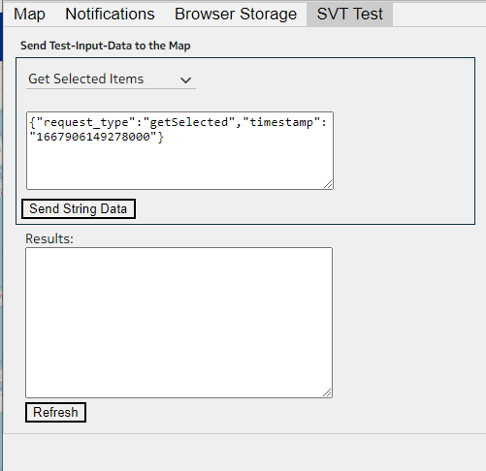

## Operation Workflow

Map covers the below listed operations. Each operation is covered in below sections with details and sequence diagram

### Map Data Map

In WP, we maintain a data map in UI which holds data about the entities of the design. The same approach to be followed in WS-P to avoid frequent API calls to get entity data. The respective entity DTO which exposed via REST API will be used and saved as it is

### Map Menu and Settings Functionalities - (Menu)

* Map Settings Functionalities
  + Enable Map
  + Zoom On Select
  + Center On Select
  + Zoom Level
  + Geo Co-ordinate System
* Map Menu Functionalities
  + Views
    - Logical Topology
  + Construction Settings
    - Fast Mode
    - Current Template (Will be depending on Template team)
    - Design Template
  + Layer Filters
    - Edges (OTU, ODU, Section will not be supported)
    - Vertices

The functionalities of the map menu items as in WP 22.07 to be retained in WS-P.

Few Menu options if changed from the default value by the User will be stored as User Preferences. This will be used while loading the Map the next time for the User

### Map Geo view and Geo-free view

User can switch between Geo view and Geo free view. User also able to move the site if it is not locked. Expected minimal changes in UI to accommodate this use case.

The geo free coordinates will be maintained internally and not shown to the user. The geo free coordinates and the geo coordinates will be the same when site is created initially.

In the UI - the label for the Location in site dialog will be updated as Location (Geo View) in geo free view

Geo-Free view implementation will be like one what we achieved in WP but with some additional corrections covered under functional workflow

### Geocoding

In WP, users can create site with address. To achieve that, user need to create geocoding with an API provider and key which will be saved in DB for later use.

So, we need to store information about the Geocoding API provider and key.

Minimal changes in UI, need to support backend changes if required. No relation with design/any EPT entity. Need a table in WS-P Database to store geocoding data. Table structure will be same as in WP

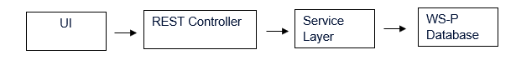

Note: Geocoding provider can be created/edited/deactivated by users with admin privilege. Other users can view which Geocoding provider is currently active.

Refer section 2.12.1 for table structure

### User Preference

The User Preference stores info about Edge/Vertices Selection, Map Position along with the User and Design details. To save the preference details, we will be using WS-P database like WP approach but with additional columns for each preference to be saved. The preferences are for example Map_settings_preference, Map_edge_prefernce, Map_vertices_preference.

The preference columns will be of type String.



Map position, Layer and Vertices menu selection are built using saved User Preference if available else with default value.

In WP, whenever user changes the Map Settings, Visible Layers/Edges the preference values will be updated. Same approach will be followed in WS-P.

Refer section 2.12.2 for table structure.

### Loading/Opening design

On opening a design all the entities present in the design are loaded in the Map.

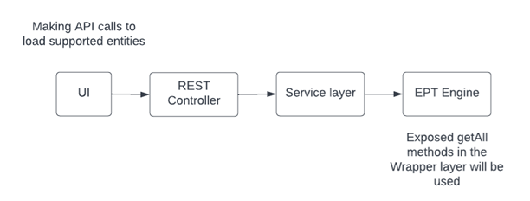

UI will handle the loading of entities in the map. The entities data will be fetched using the rest endpoints exposed by respective team working on the entity. If required rest endpoints are not available, we must work with the entity team to make them available.

We must load entity based on saved user preferences, and geocoding data if enabled, license of current user, current logged in user.

We will be using respective entity operation interface implementation to get all entities data. For example, Site we will be using getAllEptEntities() method which is under EptEngineSiteOperationsImpl which will return list of site as a WSP entity response which then will be used to build SiteDTO.

### Fast Mode Creation

For Fast mode creation WP based approach will be followed for WS-P. The fast mode creation depends on Site, Node, Segment, Demand creation methods. The creation flow of respective entity will be reused. To improve performance the creation will be done concurrently for the same entity.

The Fast mode is dependent on design default template for Site, Node, Span, Demand to create request data to send it to the respective creation method. We will depend on templates team

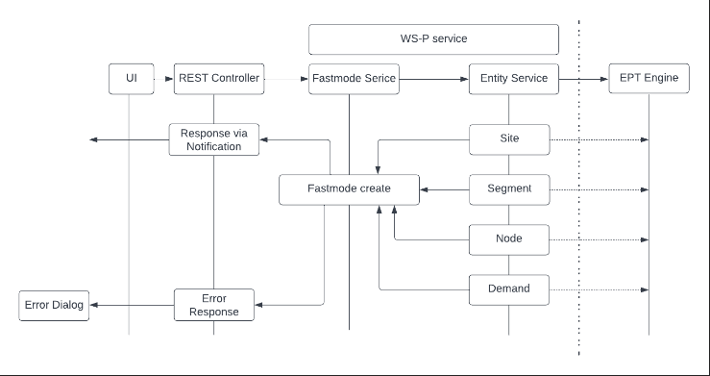

In EPT engine layer, we will be using the methods exposed under respective entity operation Interface implementation. For example, for site, we will be calling the create method in siteServiceImpl which will be using method exposed under EptEngineSiteOperationsImpl

### Layer View

The Layer view will be same as in WP. The required data will be retrieved from EPT.

The layers supported are OCH, OMS, OTS, Span.

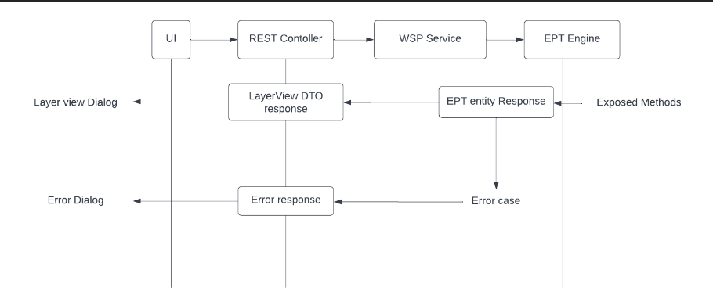

For Layer view we need route information for a trail/demand. To get routes for the trail we will get the trail by id using getById method under the respective trailEntityOperationsImpl. For ex: for OTS (SPAN in EPT) will be using method exposed under EptEngineSpanOperationsImpl.

For demand, to get routes will be using getRoutes WDMDemand model method which will be exposed under EptEngineDemandOperationsImpl.

To get Node/ShelfSet information, will be using EptShelfsetOperationsImpl and EptNetworkElementOperationsImpl for circuit pack and OT pack information of a trail.

For a feasibility, we planned to expose the method under EptEngineDemandOperationsImpl.

All the data collected will be put together in a DTO model which will be similar to routeDTO in WP

### Show Route

The layers supported are OCH, OMS, OTS, Span

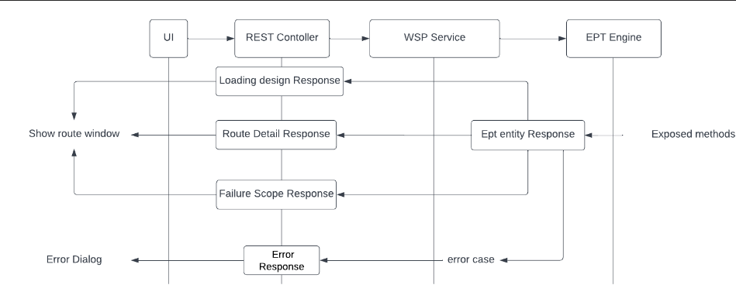

For show route we will be using method exposed for layer view, additionally for show route we need info for failure scope and its impacted and restoration routes which will be exposed under EptEngineDemandOperationsImpl and EptEngineGMPLSFailureScopeOperatonsImpl.

Failure scenario for NRA we will be depending on NRA team. Those details will be clubbed together and sent as DTO model or will call respective API based on user interactions

### Map-Icon interaction

Expected no changes in UI. This will be the user interactions with Map icons like reload, overview, zoom-in, zoom-out, maximize etc.

### Taskbar interactions and Window-window communication:

Expected no changes here but need to make sure the functionality working as in 22.07.

Taskbar interactions will be seen in Layer view, show route window which can be used to hide/show layer view dialog in view, to show controls to interact in show route window.

For window-window communication, it will be passing data across browser tabs based on the user interactions in map or in the respective dialog. Identified Usage will be in NRA dialog, failure scope dialog, system dialog, Manual routing dialog.

### Map-Mouse Interaction

* The interactions differ based on View (Identified support for System, NRA)
* The Map Mouse Interactions involve popping up menu items for entities.
* Each view will have different interactions like highlighting entities, to get marked with symbols, to send the selected data to different window on selection

WP code to be reused. Need to revisit and make necessary changes in the respective view-interactions services. Selection and Communication between window will need more work.

In WP, on selection of trail/service we will make API calls to highlight the related entities in bottom table. Need to check if the same approach required in WS-P.

### Notifications

Based on the Notifications received for create/update/delete of entities, the Map will be reloaded. Will depend on the notifications defined by the architecture team for WS-P.

## Process/Functional Flow

### Map Menu and Settings

* User can enable/disable the layer to be displayed on map in Map Menu under edges section
* User can view regen node by enabling/disabling in Map Menu under vertices section
* User can adjust fast mode construction settings in Map menu
* User can view current design templates for an entity and update it in Map menu under design templates/current templates section
* User can enable/disable Map in Map settings
* User can adjust the zoom level of an entity
* User can toggle between co-ordinate system either DMS or DD in Map settings

### Geocoding

**Condition**: User with admin privilege can create/update/deactivate Geocoding API keys.

User can create one from plan design dashboard hamburger menu under configuration section.

The allowed operations are create/update geocoding provider (**Supported Providers are Google, Bing, MapQuest**) and deactivate geocoding (will deactivate geocoding and remove all three providers from table if already created.)

### Geo view and Geo-free view

### Users can switch between geo view and geo-free view by selecting the respective menu in map context menu. Users can see geo coordinates in site creation and edit window in geo free mode, the geo coordinates and the address will be non-editable.

### Users can freely move the sites in geo-free view but for R23.7.0 it will be restricted within the map boundary. When the user moves the site in the geo free view only geo free coordinates will be updated internally, and the geo coordinates will not be disturbed. When the user edits the geo coordinates in the geo view, the non geo coordinates will not be disturbed. The bottom information table will always display geo coordinates.

### User Preference

The user can create/update the preferences for a design by modifying the values in respective map menu or settings.

### Loading/Opening design

**Condition:** The design should be checked-out.

There is no specific user operation. The entities will be loaded when user opens a design

### Layer View

**Condition:**  Demand should be routed either manually or using auto design

User can view for multiple demands

User can minimize the dialog and can view it later by clicking the tab in the task bar

User can check/uncheck layer checkbox to view/hide it in the layer view dialog

It is applicable for both service and trail

### Show Route

**Condition:**  Demand should be routed either manually or using auto design

User can view for multiple demands

User can change the route colour, visible routing layer, enable feasibility

User can view restoration routes for a specific failure scenario under a scope of type design/NRA

It is applicable for both service and trail

## EPT Engine Dependencies

Depends on EPT engine entity data for Loading Design, retrieving Route info, retrieving Layer View and Show Route details.

## Object and Data Model

* The data model for Site, Node, Span, OTS, OMS, Trail, Service will be used. We will be using the entity DTO defined by the respective teams.
* Layer View DTO / ResponseData
* Show Route DTO / ResponseData
* User Preference DB Model
* User Preference Response / Request data
* Geocoding DB model
* Geocoding Response / Request Data
* Fastmode Request Data

## Solution Context/GNP

NA

## Configuration Data

NA

## Persistence

Will be applicable for User Preference and Geocoding in WS-P DB Schema.

## Database

Describe DB usage. Identify any DB schema changes.

### Geocoding

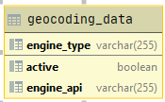

### User Preference

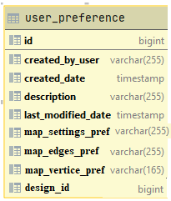

## Data Migration/Upgrade

NA

## Design Features

### Performance

Applicable for Loading Design, Layer View, Show Route, Fast Mode Creation

### Scalability

Applicable for Loading Design

### Security

Applicable for all operations.

### Concurrency

For Fast Mode creation the Completable Future API will be used.

### Error/Exception Handling

Applicable for all operations and will adopt the WS-P Architectural approach

### Disaster Recovery

NA

### Transaction Strategy

Applicable for User Preference and Geocoding.

# User Interface Design

The UI interface will be same as in WP 22.07. The screen shots below are with few changes in accordance with WS-P.

## Loading Design

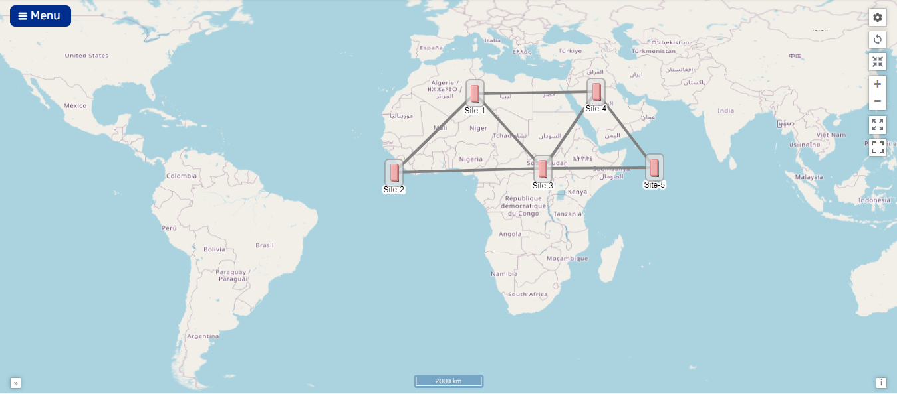

## Map Menu & Map Settings

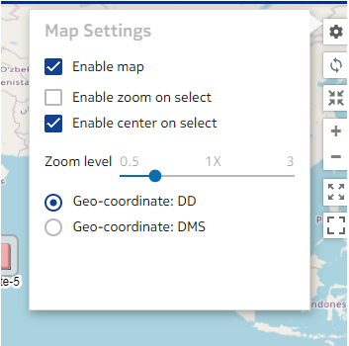

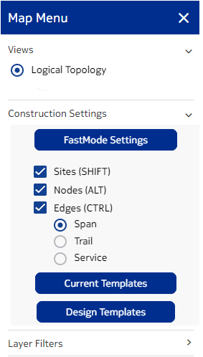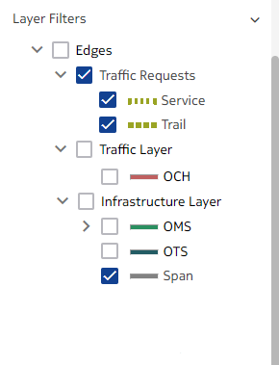

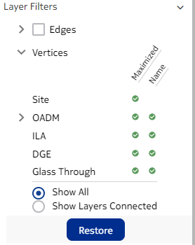

## Map Mouse Interactions

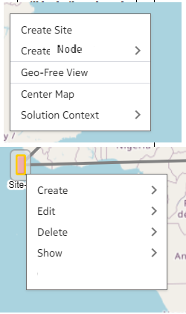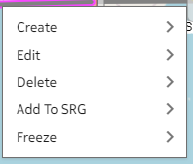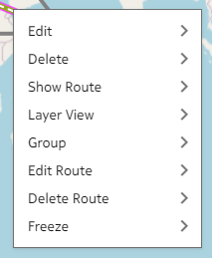

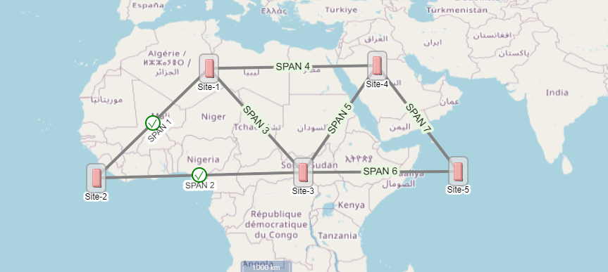

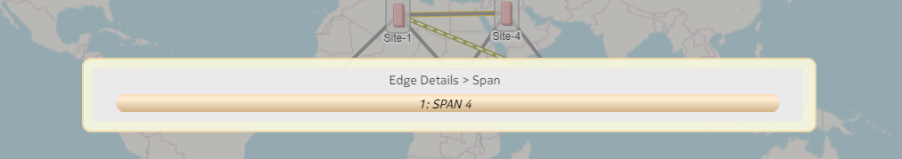

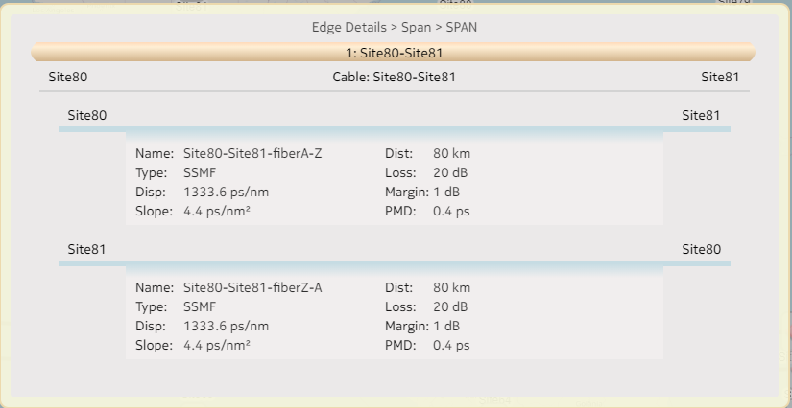

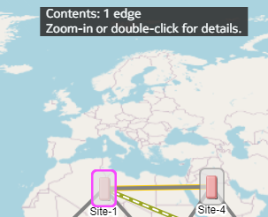

## Map Geo-free view:



## Moving site

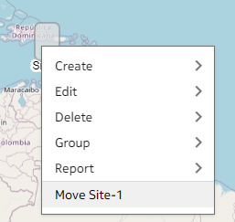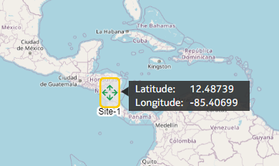

## Layer View and Show Route

Trail

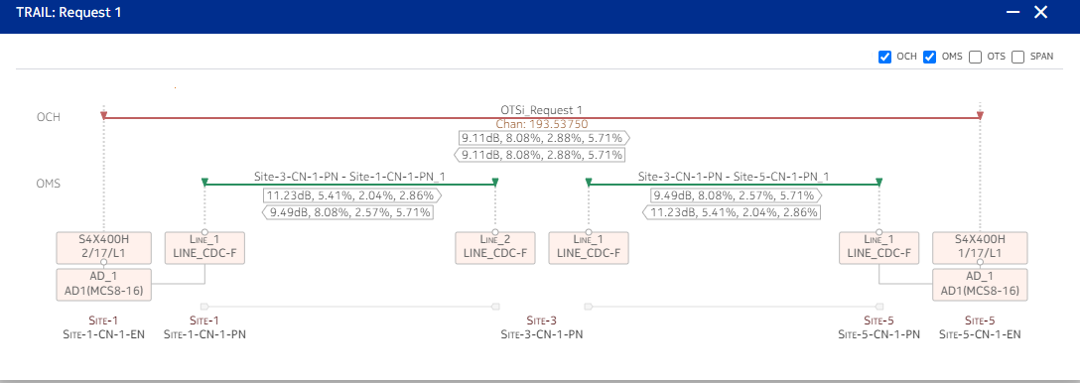

Protected Trail

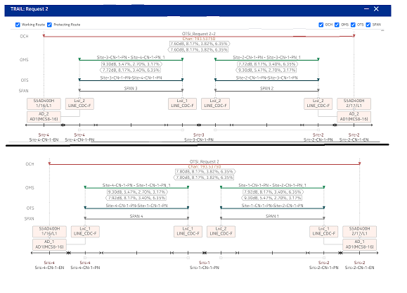

Service

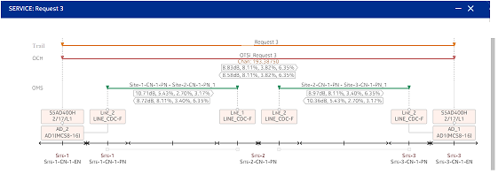

Show route

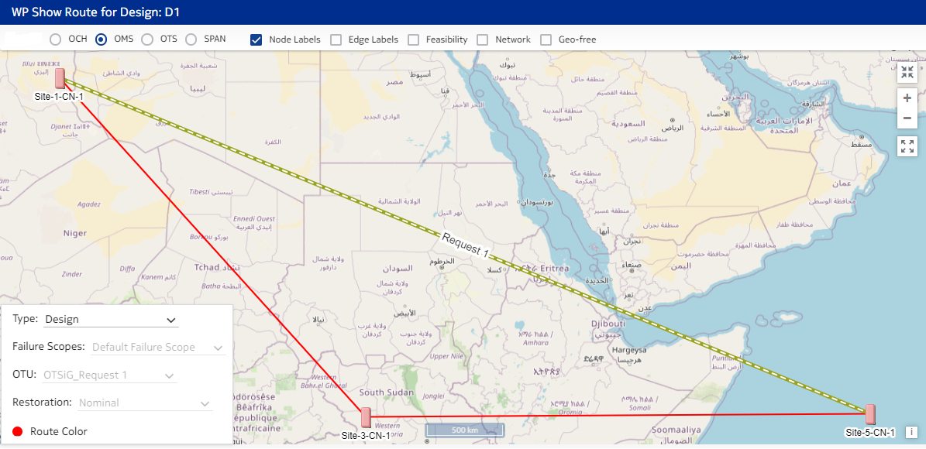

Protected case

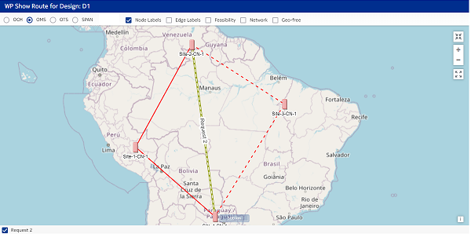

Restoration

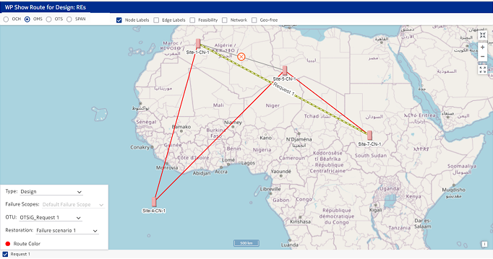

## Geocoding

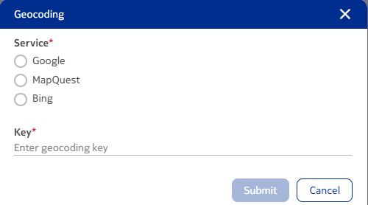

# REST Interface

## Loading Design

|  |  |  |  |
| --- | --- | --- | --- |
| **API Type** | **URL** | **Response Type** | **Request Type** |
| Get | @GetMapping("/designs/{designId}") | Design | None |
| Get | @GetMapping("/sites") | Site DTO | None |
| Get | @GetMapping("/nodes") | Node DTO | None |
| Get | @GetMapping("/nes") | Ne DTO | None |
| Get | @GetMapping("/trails?layer={ntwLayer}”) | Trail DTO | None |
| Get | @GetMapping("/demands”) | Demand DTO |  |

## FastMode

|  |  |  |  |
| --- | --- | --- | --- |
| **API Type** | **URL** | **Response Type** | **Request Type** |
| Post | @PostMapping("/fastmode") |  | FastMode Request data |

## Preferences

|  |  |  |  |
| --- | --- | --- | --- |
| **API Type** | **URL** | **Response Type** | **Request Type** |
| Get | @GetMapping("/preferences") | User Preference Response Data |  |
| Put | @PutMapping("/preferences”) |  | User Preference Request Data |

## Geocoding

|  |  |  |  |
| --- | --- | --- | --- |
| **API Type** | **URL** | **Response Type** | **Request Type** |
| Get | @GetMapping("/retrieve/geocodingData") | GeocodingData | None |
| Create | @PostMapping("/geocodingData") | GeocodingData | GeocodingRequestData |
| Update | @PutMapping("/geocodingData") | GeocodingData | GeocodingRequestData |
| Deactivate/ Delete | @DeleteMapping("/geocodingData") | Void | Void |

## Layer View and Show Route

|  |  |  |  |
| --- | --- | --- | --- |
| **API Type** | **URL** | **Response Type** | **Request Type** |
| Get | @GetMapping("/routes") | Route DTO |  |
| Get | @GetMapping("/routesHierarchy") | Layerview DTO |  |
| Get | @GetMapping("/failurescopes") | Failurescope DTO |  |
| Get | @GetMapping("/trails/{trailId}/restorationRoutes") | Route DTO |  |
| Get | @GetMapping(“/failureScenarios/{id}/impactedResources") | Entity DTO |  |
| Get | @GetMapping("/designs/{designId}/nras") | NRA DTO |  |

# Test Strategy

The use cases will be tested using Cucumber Feature.

For Showroute and layer view:

* Will be checking routes API returning correct response data
* Will be checking layerview DTO API response data
* Will be checking restoration routes API for a failure scenario

For loading design:

* Will be checking the respective entity read API returning correct response

For Fastmode:

* Will test the fastmode API
* Will ensure the entities are created properly with fastmode

For Geocoding and user preferences:

* Will be checking create,update,read and delete operations call
* For preferences will check if all preferences are deleted if a design got deleted.

# Open Issues

* Heat map will not be supported
* Search and Advanced search functionality will not be supported
* ODU, OTU, Section layers will be removed from Map
* The naming convention need to be confirmed
* SVT testing functionality will not be supported
* For layer view, needed confirmation on the layer to be supported
  + Proposals:
    - For Trail -> Trail, OCH, OMS, OTS, Span
    - For service -> Service, Trail, OCH, OMS, OTS, Span
* Needed confirmation on show route requirements on functionalities

# Appendix

## Configurations not supported or limitations

## PlantUML or Other Files for Diagrams in the Design Document

# Review Comments

Track all the review comments here.